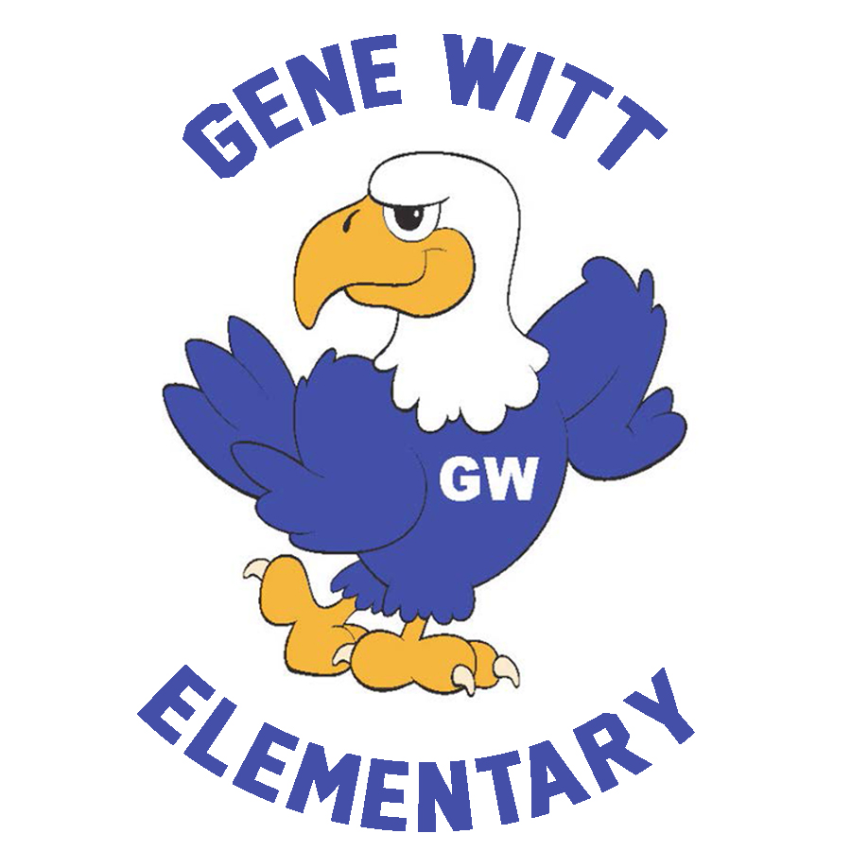
2023-2024 PTO Board
Carla Santoro – President
Kiley Cannon – Vice President
Shannon Cooley – Treasurer
Mike Lynch – Recording Secretary
Cara Misiewicz – Corresponding Secretary
genewittpto@gmail.com / www.genewittpto.com / Facebook

Call to order at 7:01pm

PRESIDENT’S REPORT (Carla)

- Board Introductions – Carla provided an introduction of the new board.
- Opening comments – Carla provided an oversight of the role of the PTO Board and the PTO members, including the need for parent involvement to make things successful.
- Two Date Changes – Otis Spunkmeyer kickoff is 9/14 and Volunteer information meeting is 9/15
- Bingo Night – Bingo night is this Friday 9/8

TREASURER’S REPORT (Shannon)

- Budget – Shannon explained that we are using a new system this year and that the 23-24 budget will be approved at the Oct PTO meeting.
- New Mini Grants – No new Mini-Grants to approve for Sept but there was discussion about what a mini grant was and how they can be used.
- Business Sponsors – We are working on acquiring our business sponsors for 23-24

MINI GRANTS – AUGUST (Carla) – All August mini grants we reviewed and approved

- Front Garden – School Improvement
- Concrete Pad – Gene Witt Dining – School Improvement
- Concrete drainage slop pad – School Improvement
- Books – All Teachers & Staff
- Refrigerator/Freezer Combo – PE
- Gardening Supplies – K-5 ESE
- Fluency and Fitness Licenses – 2nd Grade

CALENDAR (Carla) – Reviewed all the upcoming calendar events.

- September 8: Family Bingo Night (6PM-8PM)
- September 14: Otis Spunkmeyer Kick Off Party
- September 15: Volunteer Information Meeting (9AM – 10AM)
- September 29: Otis Spunkmeyer Orders Due
- October 5: October SAC/PTO Meeting (6PM)

Added to the calendar – OCTOBER 18 – EXTENDED BOOK FAIR HOURS AND FOOD TRUCK RALLY –
Food truck rally 5pm to 8pm – Car Rider line entrance
Book Fair 4:30pm to 7:30pm – Media Center
Mike discussed the upcoming food truck rally and shared that the following food trucks have already accepted the invitation to attend. We are waiting on the addition of one more possible dessert truck.
- Kona Ice
- Deez Diner - https://www.facebook.com/deezdiner22
- North River Pizza - https://www.northriverpizza.com/
- Wingz and Thingz - https://www.facebook.com/wingzzNthingzz

VOLUNTEER OPPORTUNITIES (Carla) – Reviewed the upcoming meeting and high level role of the volunteers

- Volunteer Info Meeting
- Sign Up Genius
- Point Person
- Fathers Being Involved (FBI) – Mike discussed the role and needs of the FBI around Gene Witt

NEXT SAC/PTO MEETING

October 5, 2023 @ 6PM in the Media Center

Meeting adjourned at 7:26 pm.

