10/5/23 Meeting Minutes
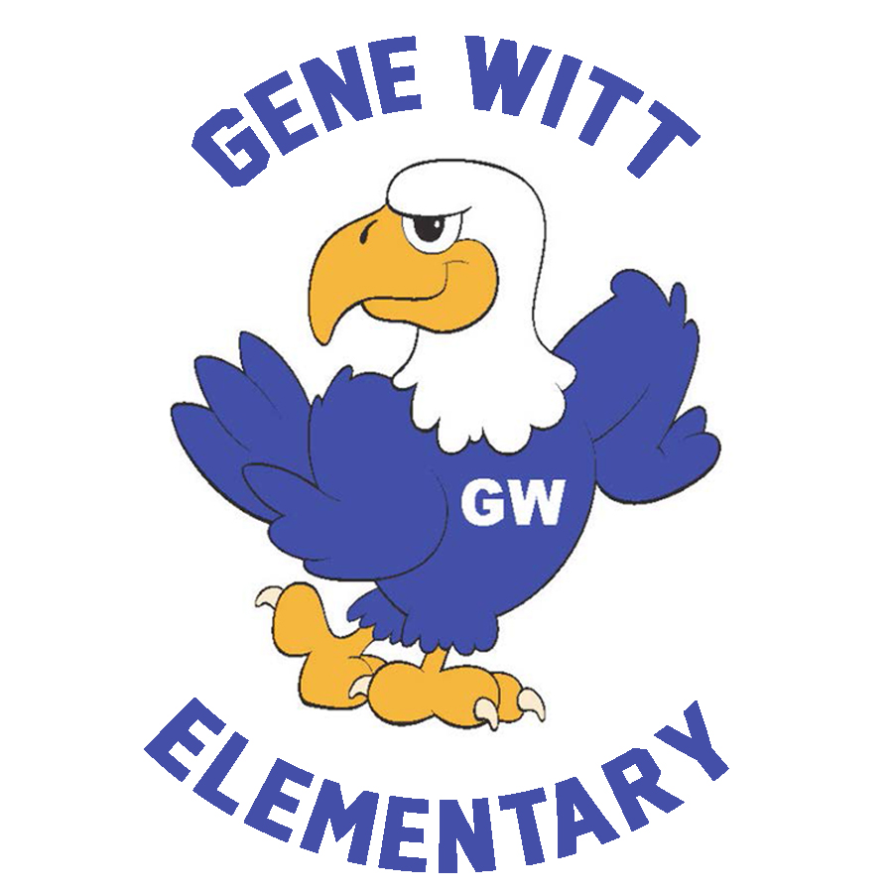
Gene Witt Elementary PTO

Date: October 5, 2023 6:00 PM
Location: Gene Witt Media Center
WELCOME

Call to Order at 7:14pm

OLD BUISNESS

- BINGO NIGHT – Carla provided update including that 241 people attended.
- OTIS FUNDRAISER – Carla provided update including preliminary numbers of $48k in sales
- SPIRIT GEAR – New order should be arriving at school on 10/9 and order form will be sent home.
  - Additional sizes have been ordered and should be in soon.
  - All orders that have not been filled, will go home as soon as the shirts are received
  - Thank you for your patience
- BUSINESS SPONSORS – Carla stated that we presently have 14 business sponsor with more to come.
  - We currently have 12 Business Sponsors with a couple more requests pending.
    - 10 VIP Level
    - 2 Blue Eagle Level

NEW BUSINESS

- STOCK THE PANTRY – Carla stated that the pantry would be stocked on 10/16 with a cut off date of 10/12
  - We will be asking for monthly donations to stock the teacher’s lounge.
  - A signup genius is on FB today
  - A donation bin is in the front lobby
- BOOK FAIR – SCHOOL EVENT – Carla discussed the book fair and reminded of the signup genius
  - October 16 – 20 8am – 3pm in the Media Center
  - Extended Hours on October 18th 4:30pm – 7:30pm (in coordination with Fall Food Truck Rally)
  - Parents may shop with the students before school or at lunch.
  - No students will be allowed to shop on their own before school.
  - A signup genius for volunteers will be posted on FB on Friday.
- FALL FOOD TRUCK RALLY – Mike discussed the food truck rally and the food trucks that would be there.
  - October 18th – 5pm – 8pm
  - 5 vendors – something for everyone!
- TRUNK OR TREAT – Carla reminded everyone that the candy donations are still needed and the box is in the front office.
  - October 27th – 6pm – 8pm
  - Ways to be involved
    - Candy donations – Feed the candy monster in the front office.
    - Decorate your trunk and hand out candy – signup genius is on FB.

- VOLUNTEER REQUEST – CALLING ALL ARTIST! - The PTO is looking for someone or people to repaint the map in front of the office.
  - We are looking for someone to touch up the sidewalk map at the entrance to the front office. Also, to add Hawaii and Alaska back to the map.
  - Anyone interested in donating their talent and time, please email Genewittpto@gmail.com

TREASURER’S REPORT

- Budget – Vote on 23/24 Budget
- New Mini Grants
MINI GRANTS - SEPTEMBER

- 18 Books to read to student – EPK Classroom
- Flexible Seating – 4th grade classroom

CALENDAR

- October 11 – Q1 Student Celebration – Kona Ice.
- October 13 – Record Day – No School
- October 16 – 20 – Fall Book Fair
- October 18 – Extended Book Fair Hours (4:30pm – 7:30pm)
- October 18 – Fall Food Truck Rally (5pm – 8pm)
- October 24 – School Picture Retake Day
- October 27 – Fall Parade
- October 27 – Trunk or Treat (6pm – 8pm)
- November 1 – Early Release (1:50pm)
- November 2 – SAC/PTO Meeting (6pm)

PTO INFORMATION

BOARD MEMBERS :
President - Carla Santoro
Vice President - Kiley Cannon
Treasurer - Shannon Cooley
Corresponding Secretary - Cara Misiewicz
Recording Secretary/ FBI - Mike Lynch

EMAIL – GENEWITTPTO@GMAIL.COM
FB GROUP – GENE WITT PTO (be sure to answer questions before requesting to join)
ONLINE – GENEWITTPTO.COM

