11/2/23 Meeting minutes
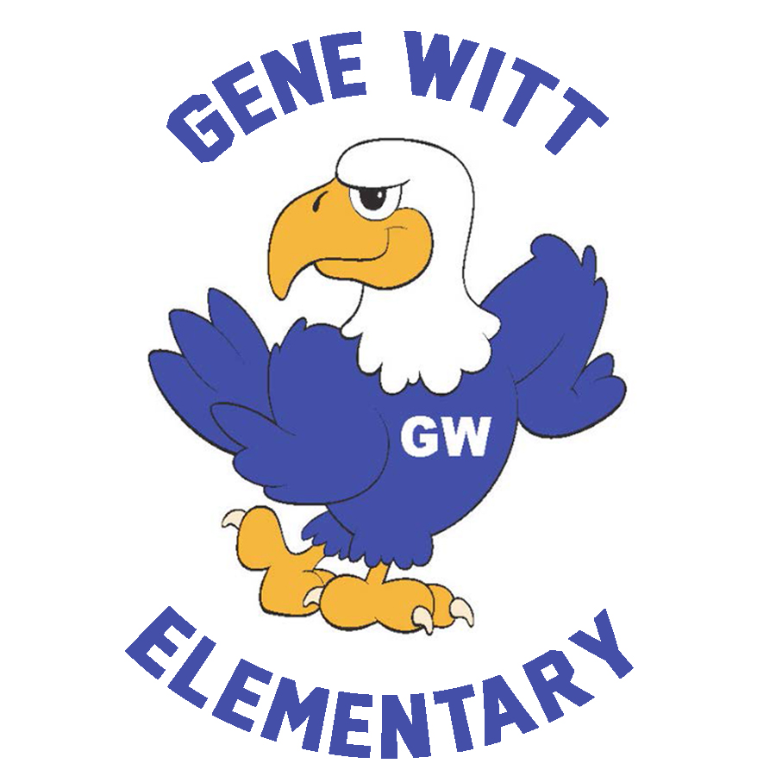
Gene Witt Elementary PTO

Date: November 2, 2023 6:00 PM
Location: Gene Witt Media Center
WELCOME

Call to Order at 6:20pm

OLD BUISNESS

- STOCK THE PANTRY – Shannon Provided update on all the effort that was done on the stock the pantry
  - Thank you to our chair Kristina Hymann and her helper Kim Sharp for organizing Stock The Pantry. The container was overflowing this month.
  - Thank you to all the GW families that donated a snack item or drink! It feels so good to spoil our awesome teachers!
  - Stay tuned for upcoming Stock the Pantry information.
- BOOK FAIR – Shannon provided the successful update including the possibility of doing an another event in the spring with the food truck Rally
  - It was one of the most successful book fairs to date!
  - Thank you to the volunteers who helped the kids shop during the week!
- FOOD TRUCK RALLY – Shannon provided the food truck rally update
  - Thank you to everyone who came out and supported the Night Book Fair and Food Truck Rally. It was a huge success.
  - Thank you, Mike Lynch for setting up the event.
- TRUNK OR TREAT Shannon provided the update and thanked all the people that volunteered their time and donated to this great event
  - Thank you, Jenna Monaghan for Chairing this event.
  - 22 Trunks, 20K pieces of candy and a night of fun!

NEW BUSINESS

- MORNINGS WITH MOM/MOTHERLIKE FIGURES – Shannon reminded everyone that they MUST RSVP to be allowed into the event and also stated that the dates and last names are guidelines and that if necessary you could go on the opposite date.
Mike also asked the present members to get their “dads” to volunteer as he still needed help those morning.
  - Date: 11/15 (A-L) & 11/16 (M-Z)
  - Time: 7:15am – 8:20am
  - RSVP ONLY event. – RSVPs due by 11/9 (flyers went home yesterday 11/1)
  - FBI Sign Up genius for volunteers to help mornings of event.
  - Chair – Tessa Clarkson
- SANTA’S WORKSHOP OPENING NIGHT – Shannon provided updates and also that volunteers would be needed to make this event successful.
  - Date: 12/1
  - Time: 5pm – 8pm
  - Make a night of it! Bring the family and get some early Christmas shopping done while supporting Gene Witt. Food trucks will be onsite to purchase dinner and dessert. Don’t forget to stop by and get your picture taken with Santa!
- SANTA’S WORKSHOP
  - Date: 12/4 – 12/7
  - Classes will have a chance to shop during the week.
  - Parents may shop with the child during lunch time.
  - Volunteers needed to help the kids shop during the week. Signup Genius link will be shared soon.
- RUNNERS CLUB – Shannon provided update and told everyone it would be on Wed mornings again.
  - Beginning Date – 1/24/24
  - Time – 7:40am – 8:00am
  - Registration form will be going home this month.
- GENE WITT FACEBOOK GROUP
  - Please answer the questions and join the GENE WITT PTO FB Group to stay up to date with all things PTO.
  - We created this group for security reasons. Please do not share posts with dates and times on neighborhood FB pages.

TREASURER’S REPORT Shannon provide treasurer report.

  - Budget – Vote on 23/24 Budget
  - New Mini Grants

MINI GRANTS - OCTOBER

  - N/A

CALENDAR

- November 10 – Veterans Day – No School
- November 15 – Mornings with Mom (A-L), 7:15am – 8:20am
- November 16 – Mornings with Mom (M-Z), 7:15am – 8:20am
- November 20 – 24 – Thanksgiving Break
- December 1 – Santa’s Workshop Opening Night – 5pm – 8pm
- December 4-7 – Santa’s Workshop
- December 7 – SAC/PTO Meeting (6pm)

Meeting ended at 6:34pm

PTO INFORMATION

BOARD MEMBERS :
President - Carla Santoro
Vice President - Kiley Cannon
Treasurer - Shannon Cooley
Corresponding Secretary - Cara Misiewicz
Recording Secretary/ FBI - Mike Lynch

EMAIL – GENEWITTPTO@GMAIL.COM
FB GROUP – GENE WITT PTO (be sure to answer questions before requesting to join)
ONLINE – GENEWITTPTO.COM

