Meeting Minutes
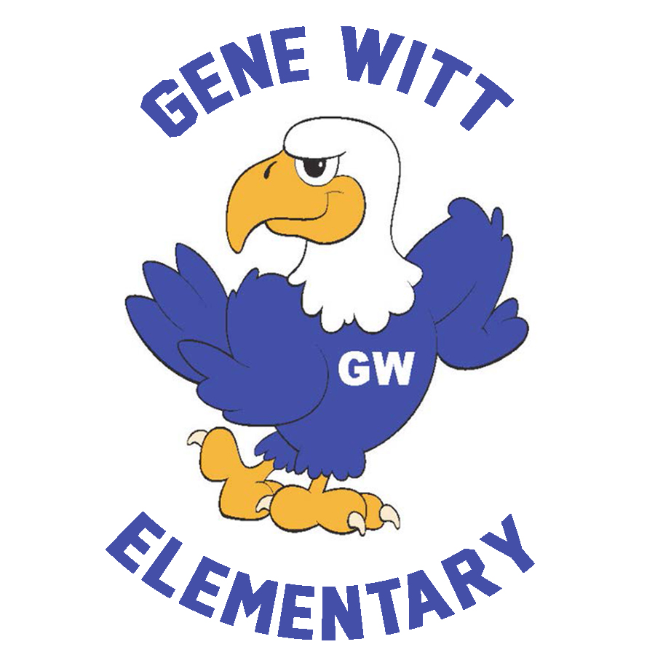
Gene Witt Elementary PTO

Date: February 1, 2024 6:00 PM
Location: Gene Witt Media Center

Call to Order 6:40PM

WELCOME

OLD BUISNESS

- RUNNING CLUB – Carla reviewed what the first day was like.
  - 120 Students participating this year.
  - Shirt will be in Friday, 2/2 and will go home Wed, 2/7 – Shirts will most likely go home Tuesday

NEW BUSINESS

- STOCK THE PANTRY
  - All donations due by Friday, February 2nd
  - Drop off in bin in the Front Lobby
- SWEETHEART DANCE Carla said they were still looking for volunteers for the event
  - February 9th from 6:30pm – 8:30pm
  - Candyland theme
  - RSVP window is closed.
  - A signup genius will be posted shortly for volunteers at the dance.
- PENNY WARS – Carla explained how penny wars worked
  - February 20th – 23rd
  - Before school – 8am – 8:20am
  - More details to come…..
- MEMORY BRICKS – Carla responded to where the location of the memory bricks were (Car Rider Line)
  - Each year GW families have the chance to purchase a brick to be placed on the walk way near the car rider loop. It a great way to honor a student!!
  - Forms will go home next week.
  - Due Date – February 23rd
- SPRING BOOK FAIR – SCHOOL EVENT - Will be coordinated on Tuesday 3/5 with food truck rally
  - March 4th – 8th , 8am – 3pm in the Media Center.
  - Extended Hours on March 5th, 4:30pm – 6:30pm (in coordination with Food Truck Rally)
  - Parents may shop with the students before school or at lunch.
  - No students will be allowed to shop on their own before school.
  - A signup genius for volunteers will be posted on FB.
- FOOD TRUCK RALLY
  - March 5th – 5pm – 7pm
  - 5 vendors – something for everyone!
- KINDERGARTEN ROUND UP Carla explained that roundup is from 9am to 11am (roughly) and still need volunteers
  - March 15th (No School – Record Day)
  - Volunteers needed to give tours to Kindergarten families in the morning.
- GENE WITT FACEBOOK GROUP
  - Please answer the questions and join the GENE WITT PTO FB Group to stay up to date with all things PTO.
  - We created this group for security reasons.

2024 – 2025 PTO BOARD

- All five executive board position will be open for nominations and elections. – Carla explained that they will be explaining the job responsibility and that most positions are a lot of work and will need people that will be able to dedicate the necessary time.
  - President
  - Vice President
  - Treasurer
  - Corresponding Secretary
  - Recording Secretary

- Eligibility Information: - Nominations will begin in March and elections will be in May
  - Must be a current Gene Witt Family or Faculty.
    - Current board members are eligible for re-election
  - As you consider whether to run directly or nominate another individual, please bare in mind that this is a large commitment in terms of time.
    - Each position has its own job responsibilities in addition to participating in the various events thought out the year.
    - Must be available to attend the vast majority of PTO sponsored events including evenings and weekends.

- Information regarding each position will be posted on the PTO FB Group in the coming days. If you are interested in hearing more about the board or are interested in running, please contact genewittpto@gmail.com

TREASURER’S REPORT

  - Budget

APPROVED MINI GRANTS – DECEMBER/JANUARY

  - Recess equipment storage – All Grades
  - FAME Membership – Media Center/Gifted
  - 10 Cube Seats – ESE Classroom
  - Green Party - December
CALENDAR

- February 9th – Sweetheart Dance
- February 13th – Class Picture Day
- February 19th - No School (President’s Day)
- February 20th – 23rd – Penny Wars
- March 4th – 8th – Spring Book Fair
- March 5th – Spring Food Truck Rally
- March 6th – Early Release
- March 7th – SAC/PTO Meeting

PTO INFORMATION

BOARD MEMBERS :
President - Carla Santoro
Vice President - Kiley Cannon
Treasurer - Shannon Cooley
Corresponding Secretary - Cara Misiewicz
Recording Secretary/ FBI - Mike Lynch

EMAIL – GENEWITTPTO@GMAIL.COM
FB GROUP – GENE WITT PTO (be sure to answer questions before requesting to join)
ONLINE – GENEWITTPTO.COM

